Reading School
Our Promise

Our aim is to make Reading School as open as possible to all children. We know that parents worry about the cost of sending their child to school and we want to take that worry away.

If your son is currently eligible, a free school meal will be provided. In addition, for any boy offered a place at Reading School, who is eligible for pupil premium (i.e. who has been eligible for free school meals at any point in the last six years) we will provide:

- Confidentiality: about financial arrangements with regard to your son. Assistance is given automatically with the minimum of fuss so that no family can be identified as receiving support. Our School Business Manager is there for you to talk to privately about any financial concerns.

- A £200 grant towards transport: to get your son to and from school.

- A grant of £100 per year: for compulsory school uniform (Stevensons vouchers will be provided in units of £25)

- A grant of £50 per year: for basic school sports kit.

- Free laboratory coat and goggles for Science and a calculator for Maths: essential for lessons.

- Free essential school trips: There will be no charge for educational visits that every student is expected to attend and which are integral to the school curriculum

- A grant of £250: towards one residential trip in Years 7 – 11. Additional funds may also be available through the Reading Foundation.

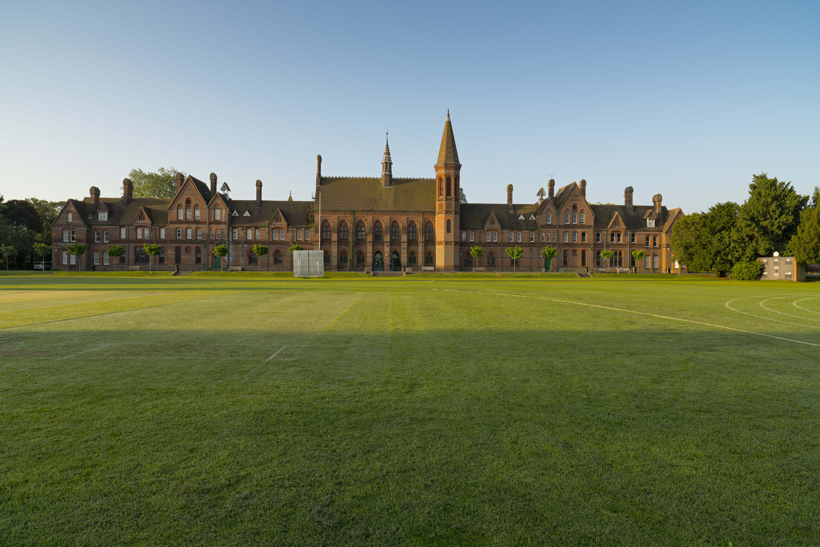
- Subsidised music lessons: up to a cost of £100 per year where individual music lessons are taken in school.

‘A positive attitude creates positive thoughts, events and outcomes. It is a catalyst and it sparks extraordinary results.’

If you have any questions or would like to discuss any concerns you have, please telephone Mr Robson, Headmaster, at Reading School on 0118 9015600 or email: headspa@reading-school.co.uk. Please contact the School Business Manager for the Reading School Promise Claim Form.

