Reading School
Forms for Completion –
Boarding Students
2019/20

Contents

Mandatory - Reply Slip – Welcome Evening and Year 7 Induction Day 3
Mandatory - Consent for Overnight Boarding Trial – 3rd July 2019 4
Mandatory – Temporary Boarding Agreement 5
Mandatory - Medical Form 6
Optional - Form for Individual Music Lessions 7
Reading School Parents Association 122

Mandatory - Reply Slip – Welcome Evening and Year 7 Induction Day

REPLY SLIPS – PLEASE COMPLETE AND RETURN TO THE ADMISSIONS OFFICER BY MONDAY 3rd JUNE BY EMAIL: phickman@reading-school.co.uk OR BY POST: Mrs P Hickman, Admissions Officer, Reading School, Erleigh Road, Reading, RG1 5LW

Name of Student: _____________________________________ Form Group: ___________________

YEAR 7 WELCOME EVENING

We are able to attend the Year 7 Welcome Evening

We are unable to attend the Year 7 Welcome Evening

INDUCTION DAY AND SLEEPOVER – 3rd/4th JULY 2019

My son will be attending both the Year 7 Sleepover on 3rd July and the Induction Day on 4th July

My son will be attending the Year 7 Induction Day on 4th July only

My son is unable to attend both the Year 7 Sleepover on 3rd July and the Induction Day on 4th July

BOARDING FAMILY BARBECUE – SUNDAY 9th JUNE 2018, 2.00 – 6.00 pm

We will be attending the Boarding Family Barbecue on Sunday 9th June

There will be …………………………………….………………………………………. people in our party

We will require ………………………………………………………..………………….. vegetarian meals

We are unable to attend the Boarding Family Barbecue on Sunday 9th June

Mandatory - Consent for Overnight Boarding Trial – 3rd July 2019

I give consent for my son to attend the boarding sleepover on 3rd July 2019

Name of Student: …………………………………………………………………………………………..

Signed Parent/Guardian ……………………………………………………………………..………….. Date ……………………….………………

EMERGENCY CONTACT 1

Mr/Mrs/Miss/Ms/Other ……………………………………………………………………………………………………………………………………….

Address …………………………………………………………………………………………………………………………………………………………………

……………………………………………………………………………………………………………………Postcode..………………………………………….

Relationship to Student: ……………………………………………………………………………….……………………………………………………….

Telephone Numbers:

Home: …………………………………………………. Work …………………………………………… Mobile ……………………………..…………..

EMERGENCY CONTACT 2

Mr/Mrs/Miss/Ms/Other ……………………………………………………………………………………………………………………………………….

Address …………………………………………………………………………………………………………………………………………………………………

……………………………………………………………………………………………………………………Postcode..………………………………………….

Relationship to Student: ……………………………………………………………………………….……………………………………………………….

Telephone Numbers:

Home: …………………………………………………. Work …………………………………………… Mobile ……………………………..…………..

Mandatory – Temporary Boarding Agreement

Name of Boarder: _____________________________________________

Reading School agrees to accept the above named pupil into the boarding community for an overnight stay on Wednesday 3rd July 2019.

I/We agree to provide the following (all items to be clearly marked with the boy’s name):

Change of Clothes
Trainers/shoes for activities in the gym
Pyjamas
Toiletries
Towel
Duvet or sleeping bag should this be preferable
Duvet cover
Under sheet
Pillow and pillow case.

I/We have ensured that my child understands that it is important for his safety and for the safety of all parties that any rules and any instructions given by the staff in charge are obeyed.

INDEMNITY

I/We agree to indemnify any member of boarding staff against:

- Any claim against him/her by a third party directly or indirectly arising out of any act or default of my child.
- Any costs and expenses reasonably incurred and/or other sums disbursed by him/her on behalf of my child during his stay in boarding.
- Any loss to him/her arising from damage to or loss of property or personal injury contributed to or caused by any act or default of my child unless so caused by negligence of the school or any of its staff provided that the indemnity shall not extend to any claim, damages, costs or expenses in-so-far as any member of staff shall be entitled to be indemnified under any policy of insurance.

Signed …………………………………………………………………………………………… Date ……………………………………………………….…..

Name: ……………………………………………………Address: ……………………………………………………………………..…………………………..

Signed …………………………………………………………………………………………… Date ……………………………………………………….…..

Name: ……………………………………………………Address: ……………………………………………………..…………………………………………..

Mandatory - Medical Form

Surname of Student: ________________________________
(Children should be registered by the surname on their birth certificate unless their name has been legally changed)
First Name(s): ………………………………………………… Preferred Name: …………………………..……..
Date of Birth: ………………………………………………….. NHS Number: …………………………………….

MEDICAL PRACTICE:
OPT IN: Please register my son at the University Health Centre, Reading.
OPT OUT: We understand that if we opt out all routine medical appointments will be our own responsibility.

EMERGENCIES: In the event of an emergency, and if we cannot be contacted, we consent for the school to act in loco parentis and for our son to have surgical procedures, or other medical/dental procedures.
Please tick the relevant boxes to give your consent on the following medication being administered. If you have not given consent to a particular medication, please give a brief explanation why:

Simple Linctus Anthisan cream
Sudafed (tablets and liquid) Petroleum Jelly
Glycerin Lemon & Honey Radian B
Antihistamine (cetirizine or piriton) Savlon Cream
Ibuprofen Calamine Lotion
Arnica Cream Paracetamol
Prescribed Medication E45 Cream

Signed Parent/Guardian: ………………………………………………………………….. Date: ……………………………………..……….

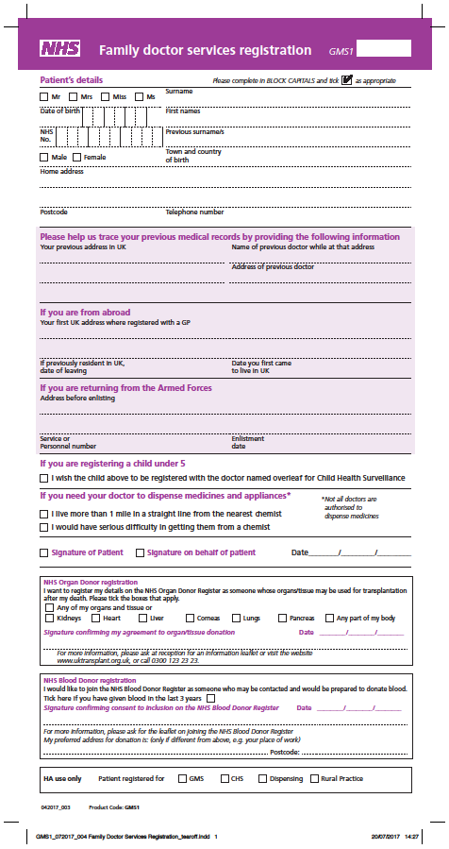

Mandatory - GMS1 Medical Form (a hard copy can be provided)
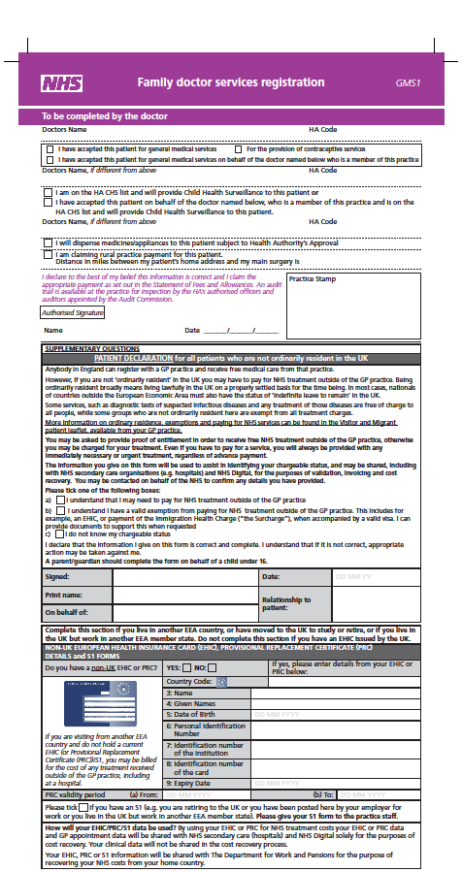

Optional - Individual Music Lessons for New Pupils
Boys are positively encouraged to take advantage of the individual instrumental/vocal tuition offered at Reading School. If you wish your son to have lessons, please complete the Request Form and return to The Director of Music. Arrangements will be made as soon as possible with an appropriate teacher but there may in some cases be a waiting list for lessons.

Tuition is available on the following instruments:

Strings  Violin  Viola  ‘Cello  Double Bass  Electric Guitar  Acoustic/Classical Guitar  Bass Guitar | Woodwind  Flute/Piccolo  Oboe/Cor Anglais  Clarinet  Saxophone(s)  Bassoon | Brass  Trumpet/Cornet  French Horn  Trombone  Euphonium  Tuba | Percussion  Drum Kit  Tuned Percussion  Piano/Keyboard | Other  Voice  Music Theory  Pipe Organ

Application for individual music lessons

Please complete the boxes below as fully as possible in BLOCK LETTERS and return to:.
The Director of Music, Reading School Email: music@reading-school.co.uk
I would like the school to arrange the following individual music lessons with a suitable member of the Reading School Peripatetic Team.

Student’s Name: |  |  |  | Form:
Instrument/Voice:
Do you already have a suitable instrument to learn on?
Would you like advice on purchasing an instrument?
The teacher concerned will provide help if necessary.
Purchases can be made through the school’s Assisted Purchase System
Please provide any musical experience your son has
including any examinations passed or currently being
worked towards.

Terms and Conditions for individual music lessons

- Lessons are timetabled weekly in rotation and normally last for 30 minutes. In cases where students have reached a high standard of playing, longer lessons may be arranged by mutual agreement. Students should receive a total of 30 lessons per year. How these are arranged may vary slightly according to the length of a particular term and student/teacher availability.

- Boys are required to plan and confirm their availability for lessons with their music teacher to ensure that timetables are arranged to everyone’s benefit. This includes due consideration to upcoming school trips, examinations and personal appointments as well as any repeated impact on academic learning.

- Where a music lesson is scheduled during an academic one, pupils must notify the subject teacher concerned by email at least 48 hours in advance or they may not be allowed to attend. Whilst every effort is made to ensure a reasonable footprint on academia, the timetable structure can present difficulties for instrumental teachers and it must be understood that it is often impossible to avoid an uneven impact on academic lessons.

- Boys wishing to learn the Pipe Organ should normally have reached Grade 4 on the piano in order for lessons to begin.

- The school has a limited number of instruments available for loan; please contact the Director of Music directly for details and associated fees. Where we cannot provide an instrument, parents are encouraged to apply to external providers after consultation with your teacher.

- Instruments should be stored in the Music School on days when they are needed. They may not be left overnight without a specific request being made in writing to the Director of Music. All instruments must be removed during half-term and school holidays. The school accepts no liability for instruments that are lost or damaged.

- The average lesson fee from September 2019 is £21 per 30-minute lesson. Please note that some fees may be higher at the discretion of the individual teacher.

- Teachers submit their bills direct to parents at the beginning of each term and parents are asked to settle their account as soon as possible and certainly within 14 days of receipt. Failure to settle an account will lead to the suspension of lessons.

- We cannot reimburse in the event of absence due to pupil sickness although teachers may use their discretion with regard to ‘catching up’ such lessons. Other potential absences should be discussed with the peripatetic teacher at least a week in advance to avoid charges.

- Notice to discontinue lessons is strictly one half-term (at least 6 school weeks) and should be provided to The Director of Music and Peripatetic Teacher in writing. Failure to provide such notice will result in a half-term’s fees being charged.

- Any changes to these Terms and Conditions during the academic year 2019-20 will be notified via the weekly bulletin.

Confirmation and Billing Information

I understand and agree that:

- My son’s lessons wil be provided on a rotational basis costing approximately £21 per 30 minute lesson and that some fees may be different at the discretion of the teacher.
- Individual music lessons take place during the academic timetable.
- ‘fixed’ lessons or lessons scheduled outside school hours are not available without prior discussion with The Director of Music and only if circumstances require.
- Should I wish lessons to stop I am required to provide a half term’s notice (no less than 6 school weeks) in writing to both the Director of Music and the Peripatetic Teacher.
- Failure to provide such notice will leave me liable for any and all outstanding fees.

Please complete the boxes below as fully as possible in BLOCK LETTERS and email to: music@reading-school.co.uk

Title: |  |  | Name:
Address: |  |  | Telephone: | Home:  Mobile:
E-mail Address:
Signature: |  |  |  |  | Date:

Reading School Parents Association
Dear Parents and Carers,
I am writing to introduce you to the Reading School Parents Association (RSPA) and would like to take this opportunity to welcome you and your son to Reading School.
There are going to be numerous opportunities (detailed below) over the next couple of months for you to meet members of the RSPA and we look forward to welcoming and assisting you even before your son officially joins the school in September. We would be very grateful if you could advise our Membership Secretary, Kirsty MacInnes, of your intended attendance at any of these events @ rspamemsec@gmail.com
We are a growing organisation with over 90% of last year's intake joining us and would like to invite you to do the same.
Our objectives are to support the school, parents and carers and students. We do this in the following ways:
- By providing a support network for the parents at carers during their time at the school.
- By supporting extra-curricular activities e.g. Junior Prize Giving & Year 13 Leavers' celebration.
- By helping enhance the school's environment e.g. funding a Multi-Use Games Area and Canopy Project to provide a covered area outside the Library. We are also currently installing new benches around the school.
- By fundraising to help fill any requirements not met by the Government budget.
- By providing essential classroom resources e.g. chemistry equipment, research laptops and leadership resources.
RSPA Communication
As a member of the RSPA we will invite you to join our communication portal Classlist. This is available as a phone or web application and is a great way to be able to send communication as an individual or as a group. Members are able to ask questions, receive notifications around important events and share information with communities e.g. boarding communities, school trips etc. You will also find it very helpful with homework clarification, lift shares, lost property tracking and generally getting support from other parents in similar situations.
You are able to follow the RSPA on a variety of social media platforms. These provide details on our fundraising achievements and events throughout the year and updates on all our activities.
Facebook
For users of Facebook you can find our page at “Reading School Parents Association”. This provides details on our events throughout the year and updates on our activities. For each school year we also have an individual page and yours can be found at “2019 Entry Parents and Carers Reading School”. You will be asked a couple of security questions in order to be able to join.
Website
The website can be found at www.readingschoolpa.org.uk.
Twitter
Please follow us at “RSPAReading”
Instagram
Please follow us at “ReadingSchoolParents”
LinkedIn
Please join our group “Reading School Parents Association Friends and Supporters”

Joining the RSPA
We would love you to join us so please complete the membership form and return with the one off membership fee to Kirsty MacInnes by post or send a scanned copy of the completed form to rspamemsec@gmail.com. Once the payment and emails have been received we will email you an invitation to join Classlist. RSPA members will be invited to join us in Big School at our Wine & Welcome evening which is held on a Saturday evening in September. This is an adult only evening which allows you a relaxed opportunity to meet with other parents and ask any questions to RSPA members and teachers. Members will be invited to this event closer to the time.

Forthcoming RSPA Events
New Starters & Parents Picnic - Sunday 23rd June
Throughout the school calendar the RSPA run a number of events including Quiz Nights, The Christmas Market and The Summer Fayre. We would like to invite you, your sons and family members to join us at the School on Sunday 23rd June from 1-3pm for our new starters and parents picnic to be held on the front field of the school. We invite you to bring a picnic (only soft drinks will be available to purchase). You will have the opportunity to enjoy the school grounds, meet members of the RSPA and other new parents. Parking is available on site. We ask, if possible, that your son wears an item of clothing in your new house colours East - Pink, County - Maroon, Laud - Light Blue, School - Dark Green, West - Yellow. This helps allow easy identification of class groups. We will also have Reading School Hoodies on sale at £20 payable in cash or by cheque to Reading School Parents Association.
Year 7 Welcome Evenings – Wednesday 26th June & Thursday 27th June
The school will be inviting you to attend information evenings on these dates. The RSPA will be in attendance to provide you with information on our activities. We are also there to support you as parents with any (non-educational) queries you may have around starting at the school. Please come and see us in the Refectory.
Year 7 Induction Day – Thursday 4th July
The school invites all boys to an induction day at school. The RSPA will be at school opening its Second Hand Uniform Shop from 2:30pm until 4:30pm. This can be found at the back of the walled carpark just before the exit to Craven Road. The shop sells school uniform items, games and PE Kit, lab coats, trainers, rugby and football boots as well as winter coats and rain coats.
Summer Fayre – Saturday 6th July
This is a whole school event and you are welcome to bring as many family members and friends to join us in the school’s beautiful grounds from 12-3:30pm. This amazing afternoon features classic cars, hot and cold food and drinks, inflatables and games for the children, tombola and grand prize raffle, an online auction, water to wine and a wide variety of items to purchase.

RSPA Meetings
Every RSPA member is welcome to attend our meetings which are usually held on the 2nd Thursday of every half term at the school. This is a great opportunity to meet other parents, get to know the school better and support your son’s educational and pastoral opportunities at the school. If you would like to be included in this forum or wish to find out any further information about the RSPA then please email me at contactus@readingschoolpa.org.uk

We look forward to hearing from you.
Best wishes
Clare Shandling
Reading School Parents Association Chair.

Optional - RSPA Membership Application Form 2019

The Reading School Parents’ Association forms a strong link with the school developing relationships between staff, parents, carers and students. The RSPA provides funds for the extra items which cannot be covered by the school’s budget.

RSPA membership is one-off fee of £50.00. A single donation which covers the whole period of your child or childrens attendance at Reading School. If you are already an existing RSPA member (Signing up when your elder son joined the school), we request that you kindly return the form without payment filled in confirming that you are opting in for your additional child or children.

Cheques to be made payable to Reading School Parents’ Association to the value of £50 and should be returned to: Kirsty MacInnes, RSPA Membership Secretary, 10 Fisher Close, Basingstoke, Hampshire, RG24 9TL along with the membership application form. Alternatively, you can send a scanned copy (not a picture of the form) of the completed membership application form to rspamemsec@gmail.com and make an online transfer directly to the RSPA bank account (sort code 601721, account number 04619919).
We are able to claim Gift Aid on membership subscriptions so if you are a UK tax payer, please can you also complete the Gift Aid declaration on the reverse of the form. This does not cost anything extra to you but helps the RSPA to claim an extra 25% back from the government.

RSPA Membership Application Form 2019

PLEASE COMPLETE CLEARLY IN BLOCK CAPITALS

 | SURNAME | FIRST NAME(S) | YEAR/HOUSE
PUPIL

BROTHERS ALREADY AT READING SCHOOL

RELATIONSHIP | Father (or guardian) |  | Mother (or guardian)
SURNAME
FIRST NAME
ADDRESS |  |  | (if different from father)
POSTCODE
TELEPHONE
E-MAIL  Please write clearly and use BLOCK CAPITALS * | 1) Father
 | 2) Mother
OCCUPATION
Separate copies of correspondence required

* By supplying your email address you agree for RSPA to have your records and contact you in future concerning RSPA events only. We do NOT pass your details to ANY other organisation.

Membership payment: (please tick)
- Paying online full membership @ £50.00 (kindly mention the date and reference of payment)
- Paying by cheque (attached) full membership @ £50.00
(If paying by cheque, kindly write your son’s name and form e.g 7C on the back of the cheque. If paying online, kindly put your son’s name in the reference box along with form name).
I agree to the detail on this form and any other form approved by the RSPA being held on computer and used as required solely by the RSPA.
Deletion of all data can be requested anytime by e-mailing: rspamemsec@gmail.com

Name: ……………………………....………. Signed: ……..…………………………..…………… Date: …….…………..…
(PTO)

Classlist
Once we have processed your membership form and confirmed payment we will forward to any e-mail addresses provided an invite to join Classlist. This is the RSPA membership communication portal, where you will be aligned to your class and year group, providing you the ability to contact other parents and also raise any questions you may have to the RSPA administrators on the system.
Gift Aid Declaration – Reading School Parents Association
For past, present and future donations
Please treat as Gift Aid donations all qualifying gifts of money made today in the past 4 years in the future
I confirm I have paid or will pay an amount of Income Tax and/or Capital Gains Tax for each tax year (6 April to 5 April) that is at least equal to the amount of tax that all the charities or Community Amateur Sports Clubs (CASCs) that I donate to will reclaim on my gifts for that tax year. I understand that other taxes such as VAT and Council Tax do not qualify. I understand the charity will reclaim 25p of tax on every £1 that I give after 6 April 2008.
Donor’s Details
Title:
First name:
Surname:
Full home address:
Postcode:
Date:
Signature:

Please notify the charity or CASC if you:
- Want to cancel this declaration
- Change your name of home address
- No longer pay sufficient tax on your income and/or capital gains

If you pay Income Tax at the higher or additional rate and want to receive the additional tax relief due to you, you must include all your Gift Aid donations on your Self Assessment tax return or ask HM Revenue and Customs to adjust your tax code.
The RSPA is a Registered Charity in E&W No. 1101822.

