Great Books For Year 6 Guide
The following books are available electronically from VLeBooks and are a great read for Year 6 pupils.
Author | Title | Genre
Annet Schaap | Lampie and the Children of the Sea | Fantasy/Adventure
Anthony Horowitz | Stormbreaker | Action/Adventure/Crime
Chris Bradford | The Way of the Warrior | Action/Adventure/Historical
Chris Bradford | Hostage | Action/Thriller/Crime
David Walliams | Gangsta Granny | Funny
Derek Landy | Skulduggery Pleasant | Fantasy/Action/Horror/Funny
Eoin Colfer | Artemis Fowl | Fantasy/Crime
Eoin Colfer | The Fowl Twins | Fantasy/Crime
James Dashner | The Maze Runner | Science Fiction/Dystopia
John Boyne | The Boy in the Striped Pyjamas | Fiction/Historical
John Flanagan | The Ruins of Gorlan | Fantasy/Adventure
Lisa Thompson | The Boy Who Fooled the World | Families/Mystery
Lisa Thompson | Goldfish Boy | Families/Mystery
Lisa Thompson | The Day I Was Erased | Families/Mystery/Fantasy
Mark Walden | H.I.V.E. | Crime/Adventure
Munroe Randall | What If? | Non-Fiction
Rick Riordan | Percy Jackson and the Lightning Thief | Fantasy/Action/Adventure
Robin Stevens | Murder Most Unladylike | Crime/Mystery/Historical
Ross Welford | The Kid Who Came From Space | Mystery/Science Fiction
Simon Mayo | Itch | Action/Adventure/Science Fiction
Siobhan Dowd | The London Eye Mystery | Crime/Mystery
Veronica Roth | Divergent | Action/Science Fiction/Dystopia
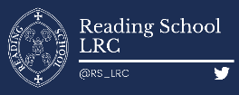

Great Books for Year 6 Guide

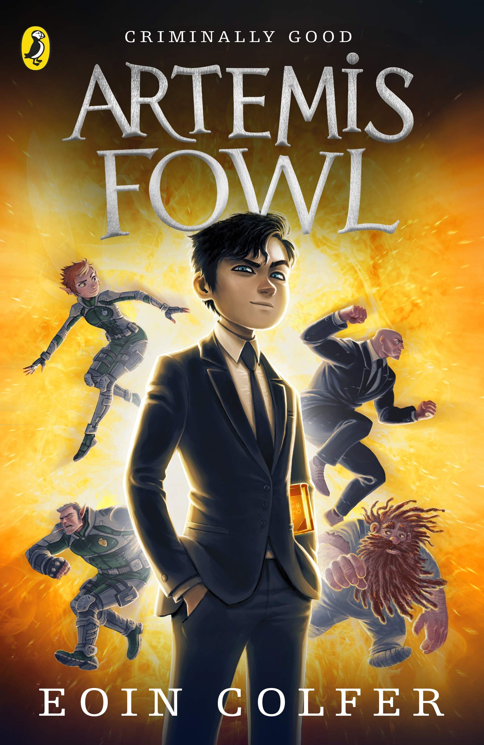 | 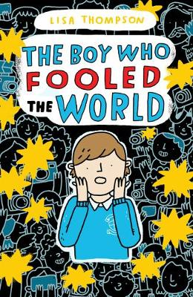 | 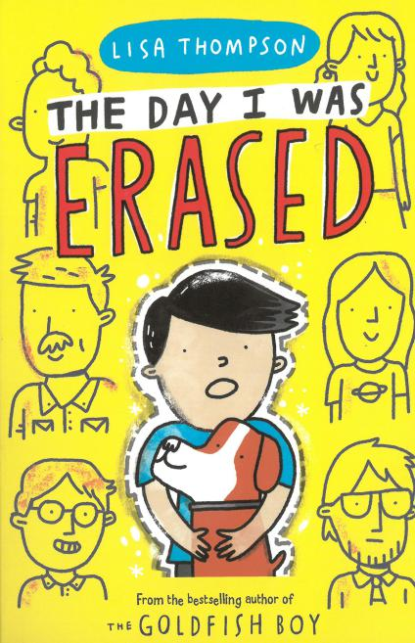 | 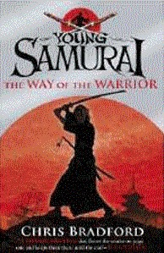
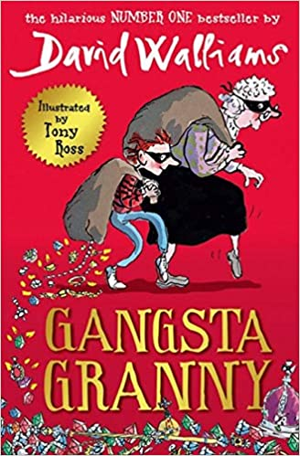 | 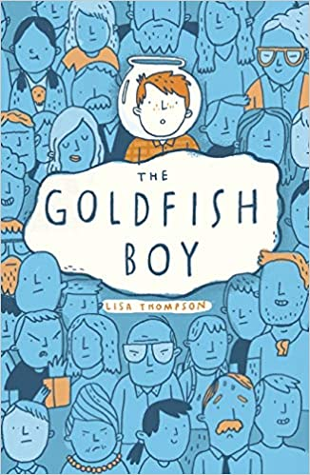 | 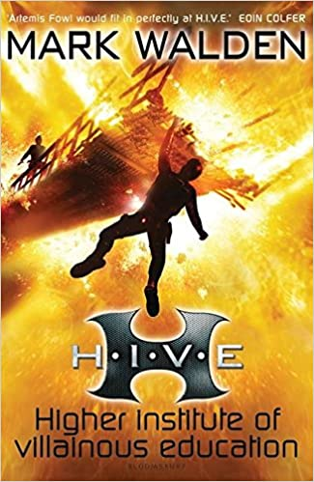 | 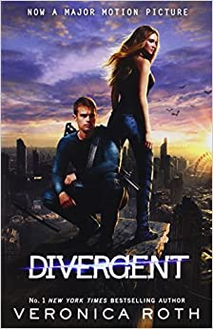
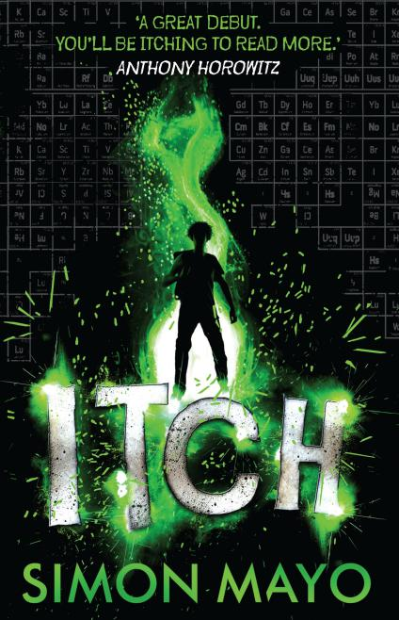 | 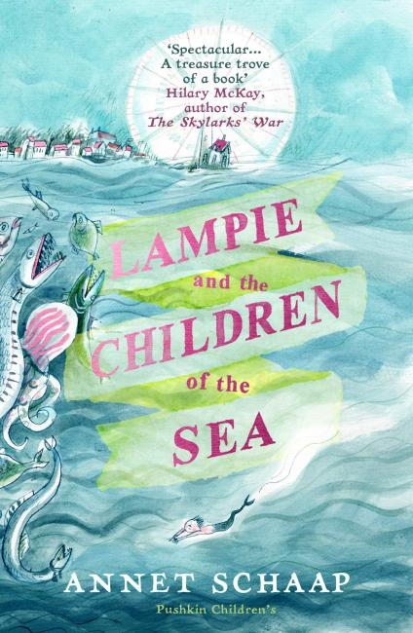 | 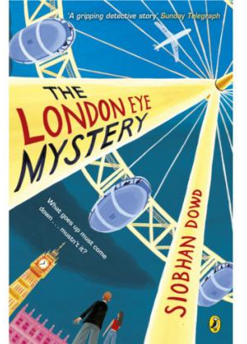 | 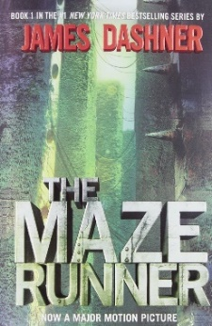
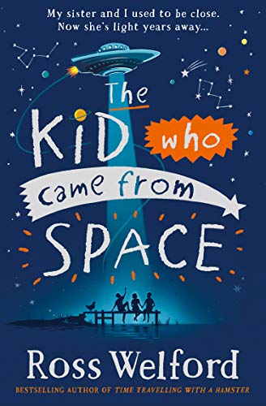 | 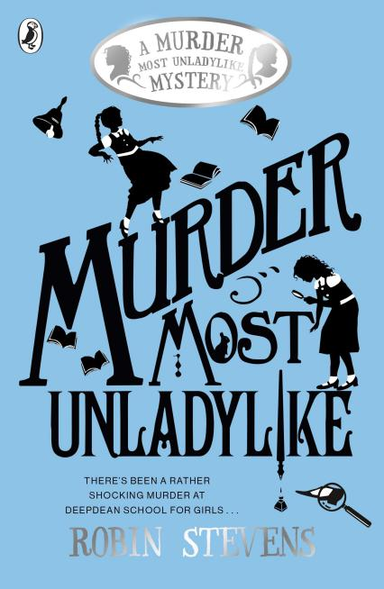 | 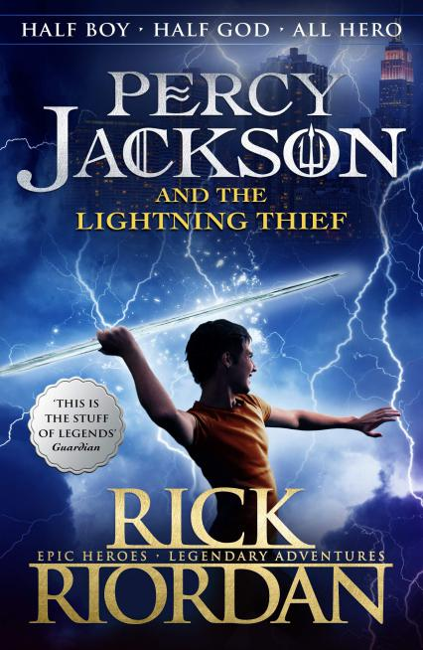 | 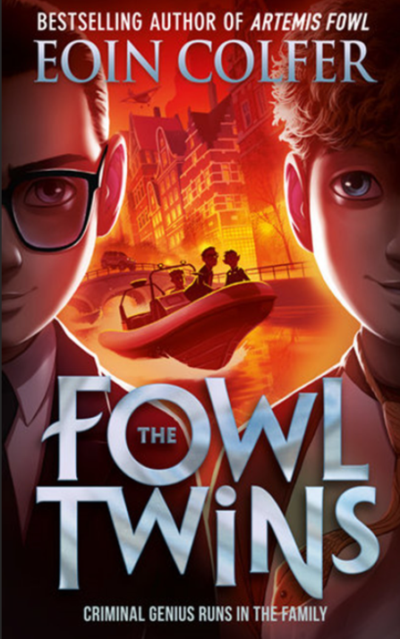
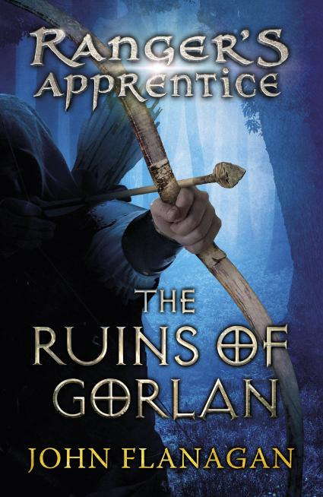 | 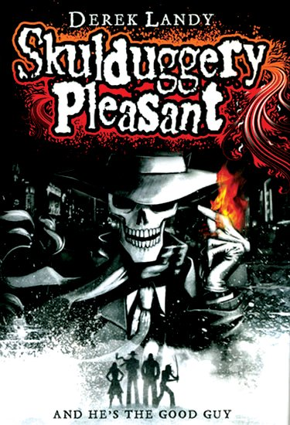 | 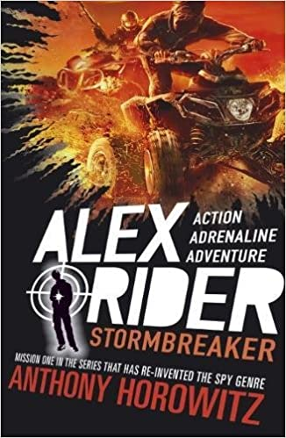 | 

