Y6 Book Photo Competition!

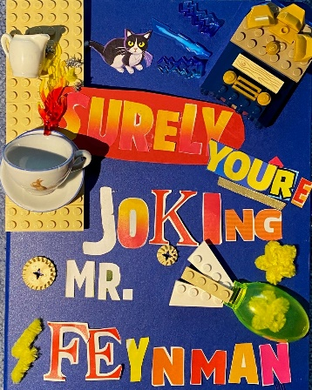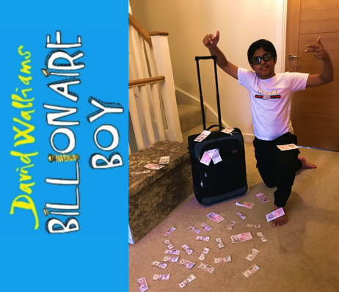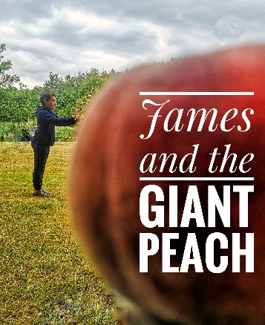

This summer, we challenge you to get creative!

- Recreate the front cover of your favourite book and take a photo
- Recreate and photograph a character or scene from your favourite book
- Take a photo of yourself reading somewhere unusual or with something unusual in the background related to the book you are reading

There will be prizes for the best individual entries and these will be put on display in the LRC during the Autumn term.
Get creative today!
Please email all entries, clearly marked with your name and tutor group to: lkesteven@reading-school.co.uk

